

**E-RECOVERY SYSTEM**

**SLN Internal System**

1. Introduction

E-Recovery system is a web based paperless system and it is provided facility to sent recoveries/allowances through the system with the authorization of relevant officer to Pay & Pension Department. System is given user friendly data entry screens to the users. Moreover it provides authentication facility, data validity checking, data availability, data integrity and tracking facility. In addition to that Users are no need to register to the system, they able to login to the system by using HRMS user name and password.

1. **User Login**

Select the User type before enter to the system.

User -For Data Entry

CO/HOD/Other -To Authorized

DDN(Pay) -To Approve

Subject Clerk - To Action

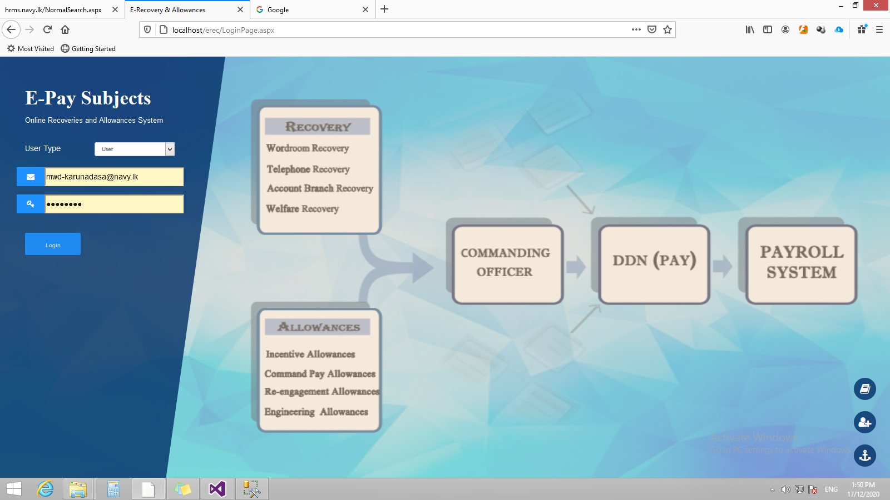

HRMS User name & Password

User Manual

1. **User**
   1. Home Page

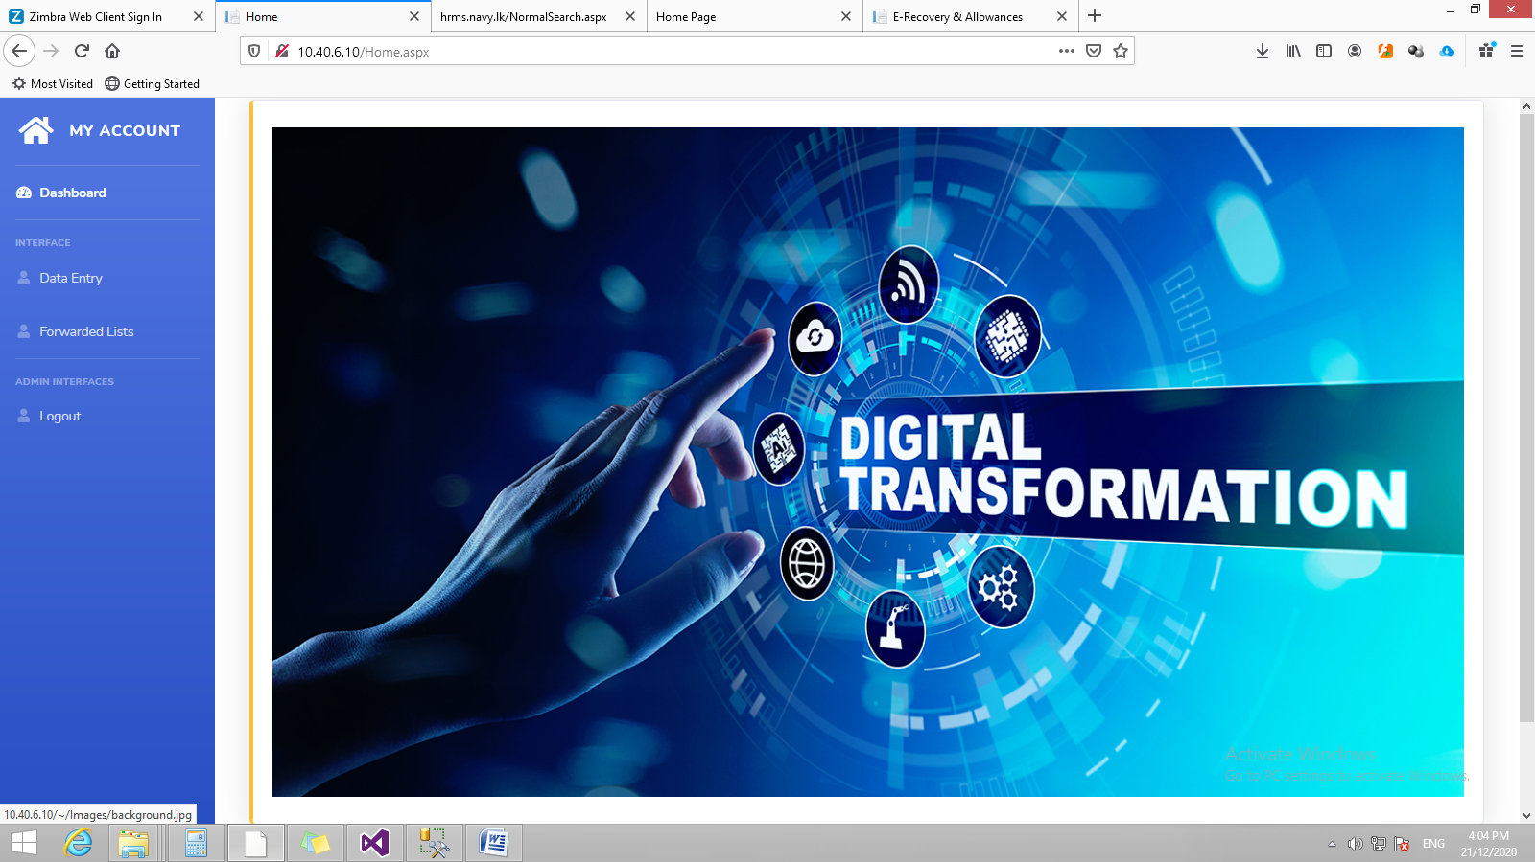

* 1. **Data Entry Page**

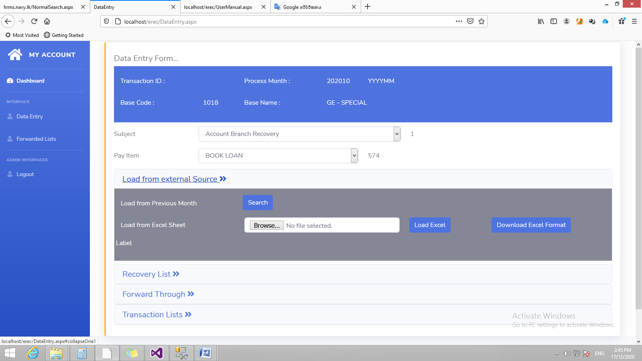

**1**

**2**

**3**

**4**

**5**

1st Step -Relevant subject should have to select form this drop down.

**1**

2nd Step -Pay items are loaded according to the subject . select the relevant Pay Item Code.

**3**

**2**

3rd Step – User can load the last month recovery list by search.

**4**

4th Step – Or User can upload recovery list from excel sheet. Excel sheet format can download from the “Download Excel Format” button

**5**

4th Step – uploaded recovery list is display here.

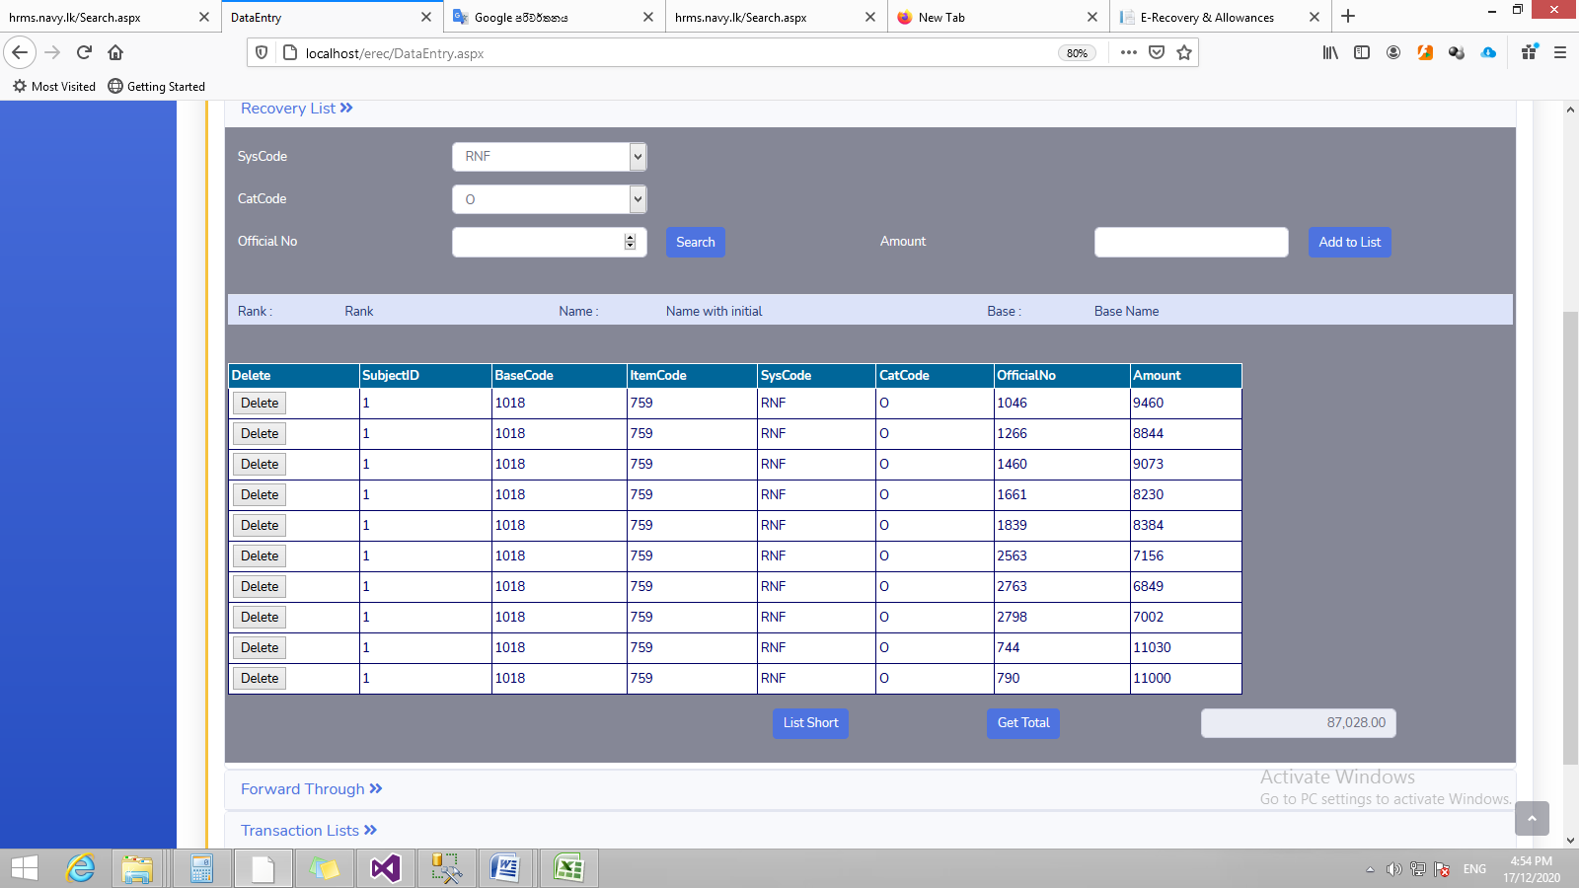

**6**

**6**

**7**

6th Step – System provide facility to add items to upload list or user make a recovery list by entering one by one with the relevant details by skipping step 03 and step 04 .

**7**

7th step – Items able to delete by click “Delete “ button.

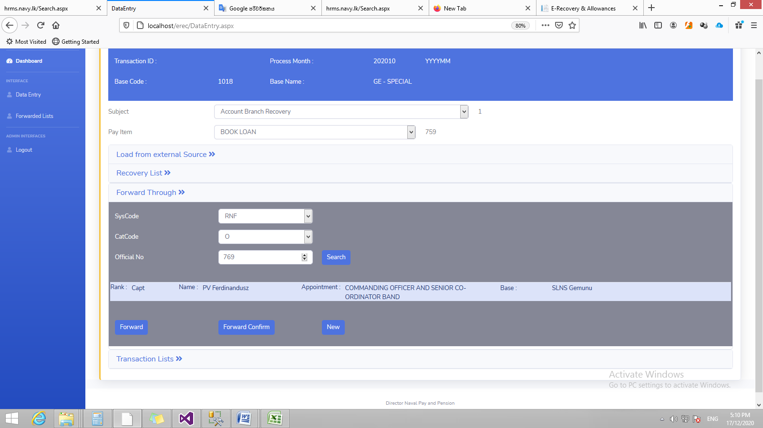

**8**

**9**

**8**

8th Step – Select the authorized person to forward.

9th Step – Forward and Forward Confirm

**9**

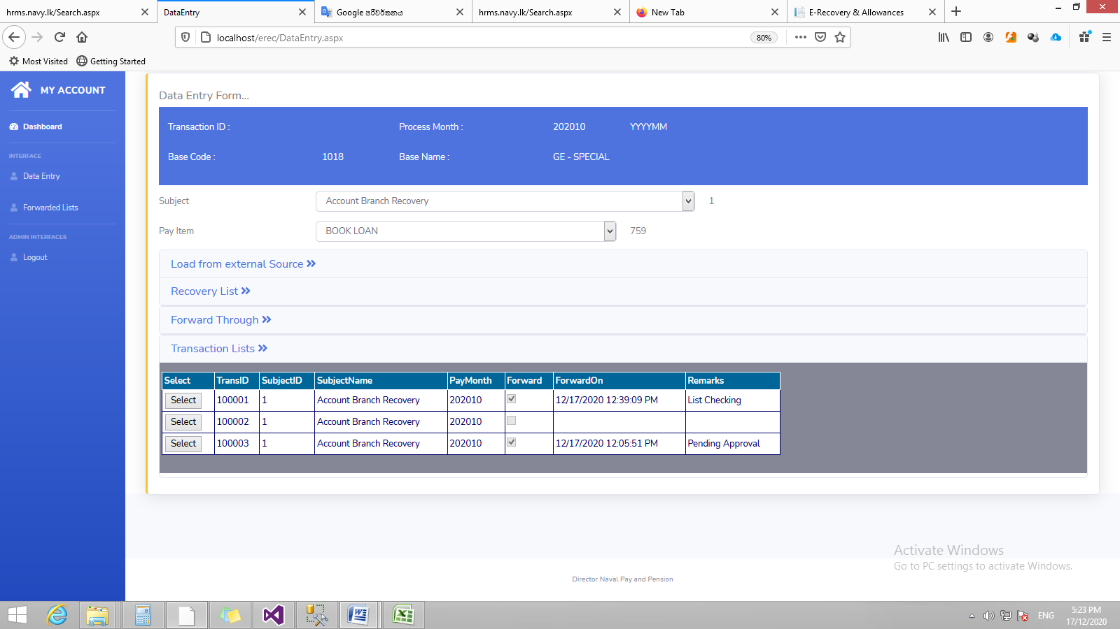

**100**

10th Step – The user can review/monitor the list of Recoveries / Allowances. Lists of Recoveries / Allowances are displayed here until do the pay process.

**100**

* 1. **Forwarded Lists**

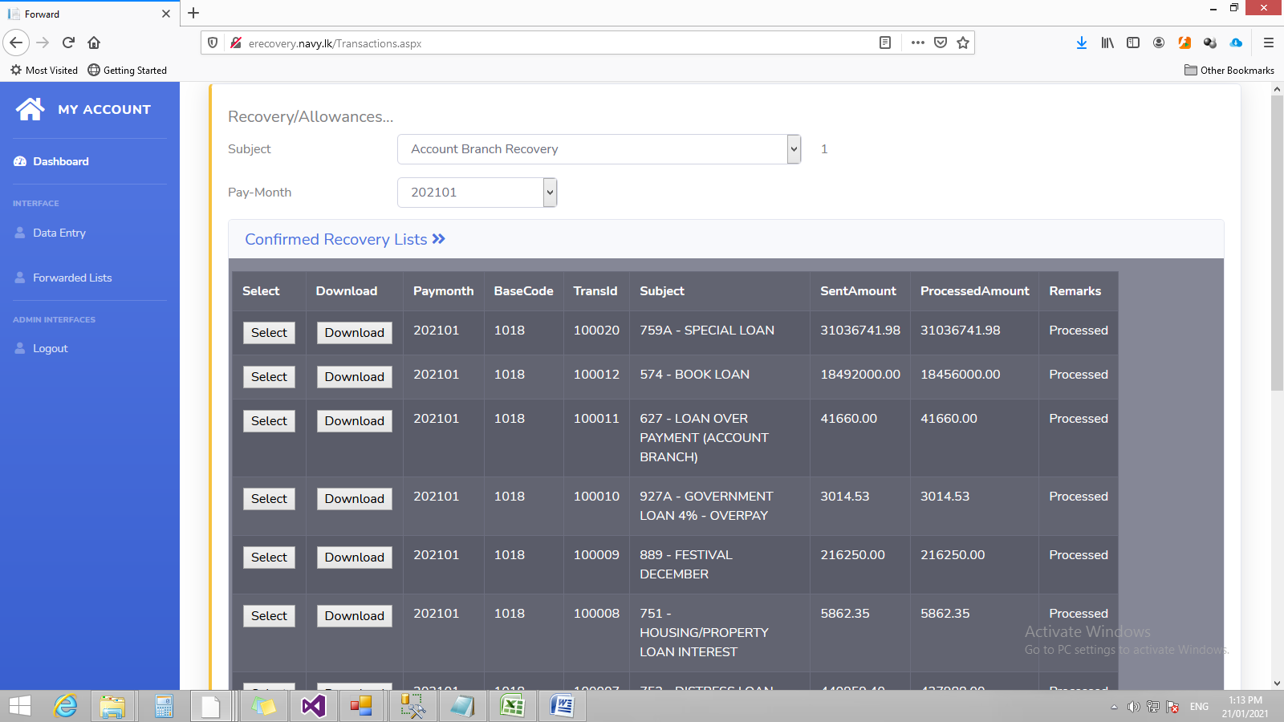

Forwarded recovery lists has been process at the relevant Pay Month and after that it display at the forwarded lists. System provides facility to download process list in pdf and excel formats.

1. CO/HOD/Authorized person’s login
   1. Recovery/Allowance Lists

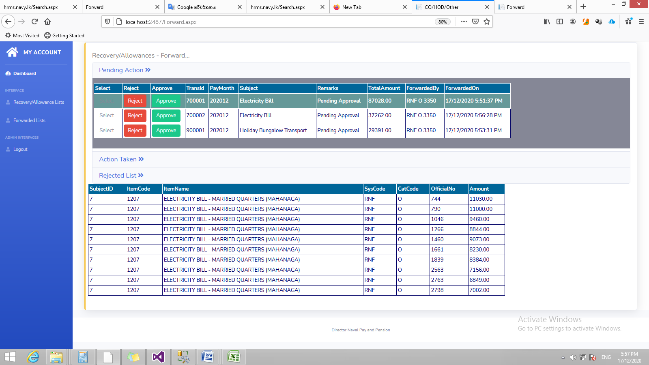

System provide facility to approve or reject the received recovery/allowance list. Further by clicking “select” button authorized person able to view all indetail . Approved and Rejected transaction lists are displayed at Action Taken List and Rejected List.

* 1. Forwarded Lists



Forwarded recovery lists has been process at the relevant Pay Month and after that it display at the forwarded lists. System provides facility to download process list in pdf and excel formats.